1. **Introduction:**

**1.1 Overview:**

This project is based on a data driven exploration of apple iPhone impact in India.

Apple has special chance to increase its market share and develop a significant presence

in India thanks to the country’s large population and rising smartphone adoption.

India one of the economies with the greatest economic growth, has seen a tremendous

increase in smartphone usage, making it an interesting market to study the effects of

Apple’s phone main product the I phone, capturing markets around the world, apple inc.

**1.2 Purpose:**

In order to shed light on important factors like market penetration, customer preferences,

Economic ramification this research data driven investigation of the impact of the I phone

in India.

**2 Problem definition &design thinking:**

**2.1 Empathy map**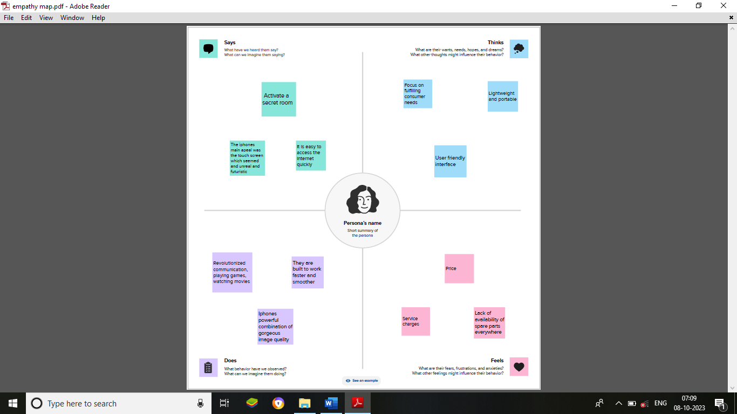

**2.2 Brainstorming map**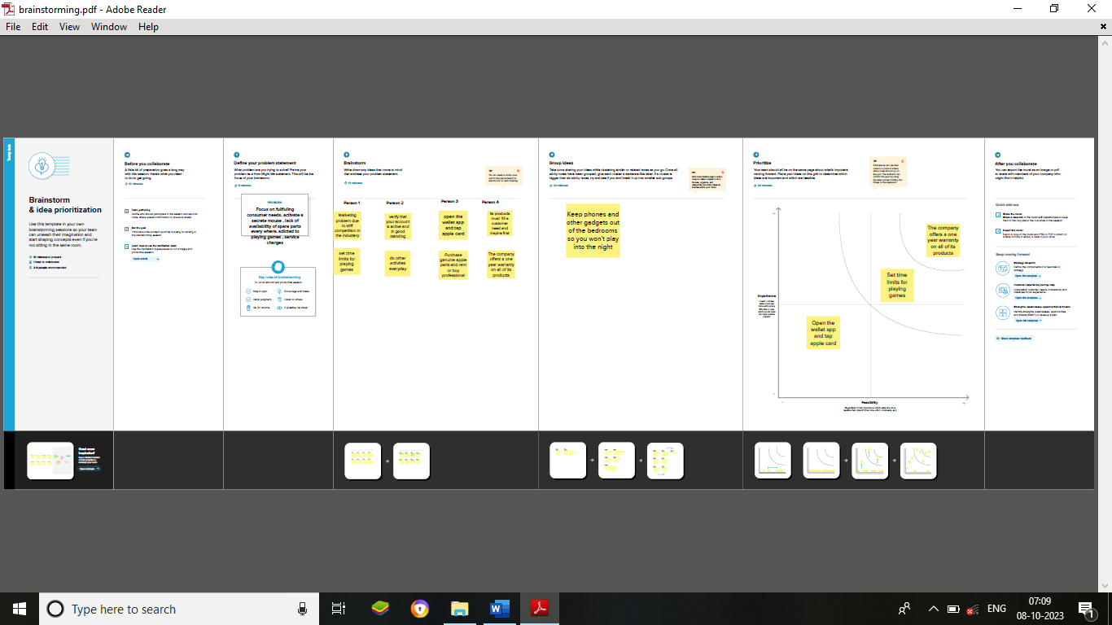

**Result:**

**Visualizations:**

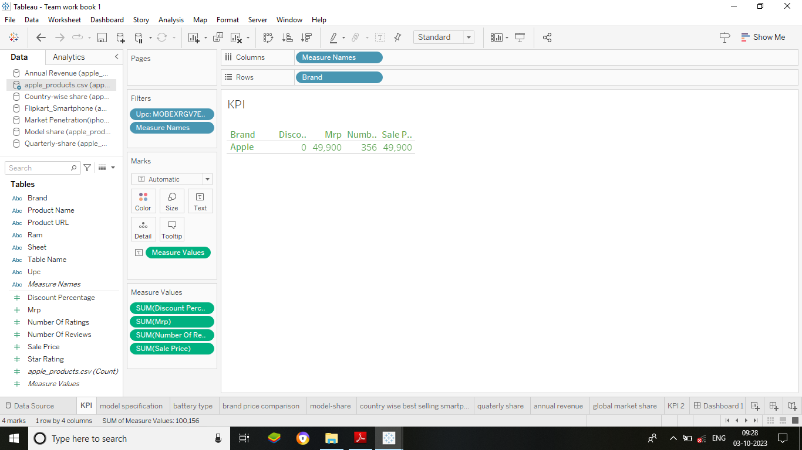

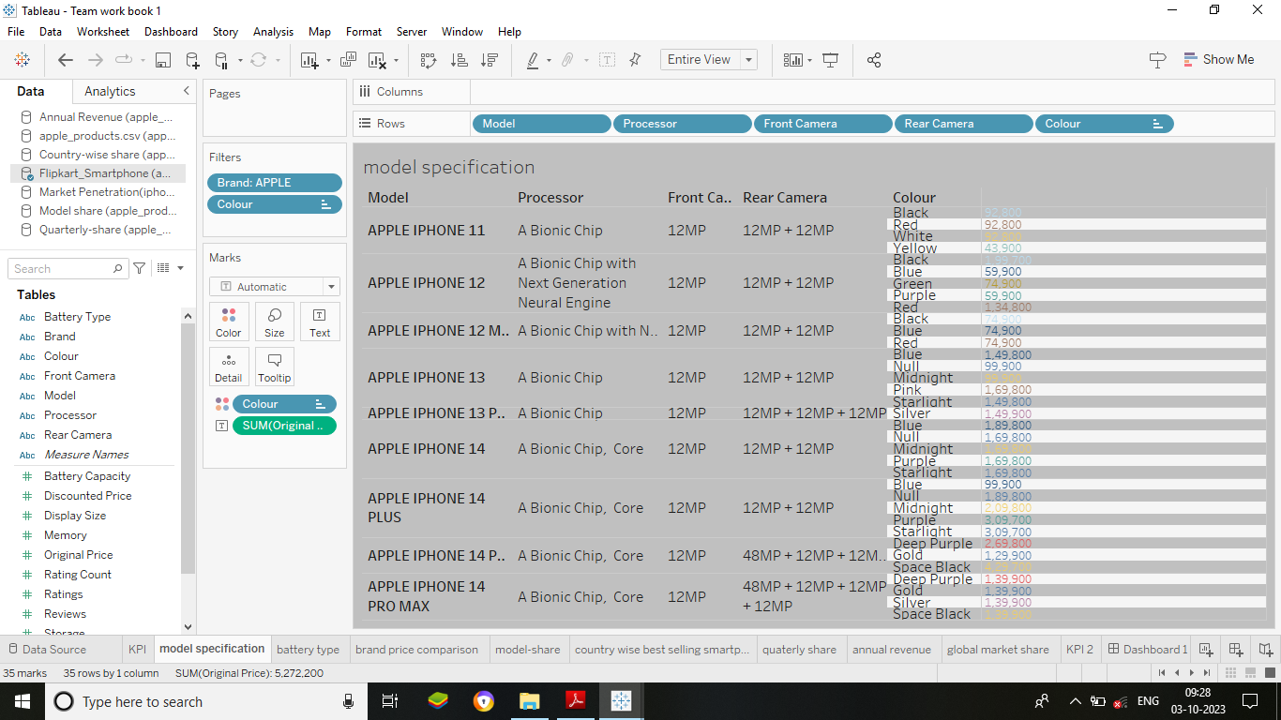

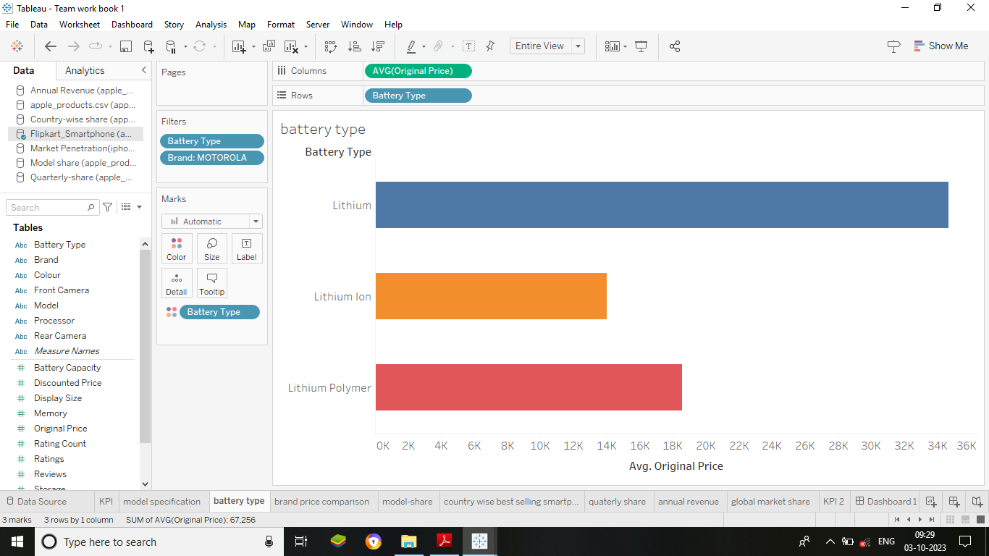

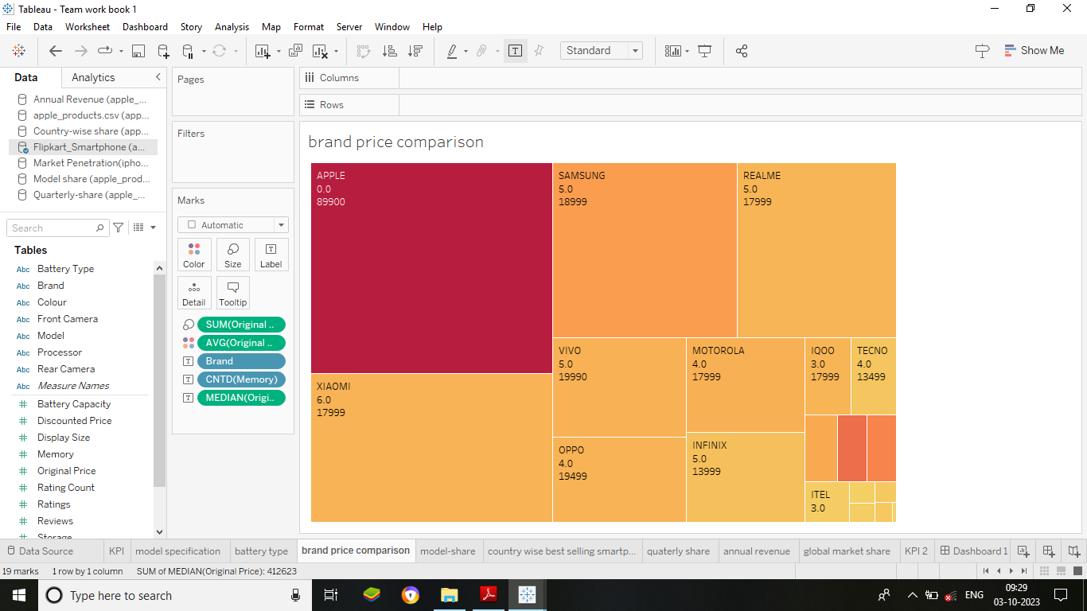

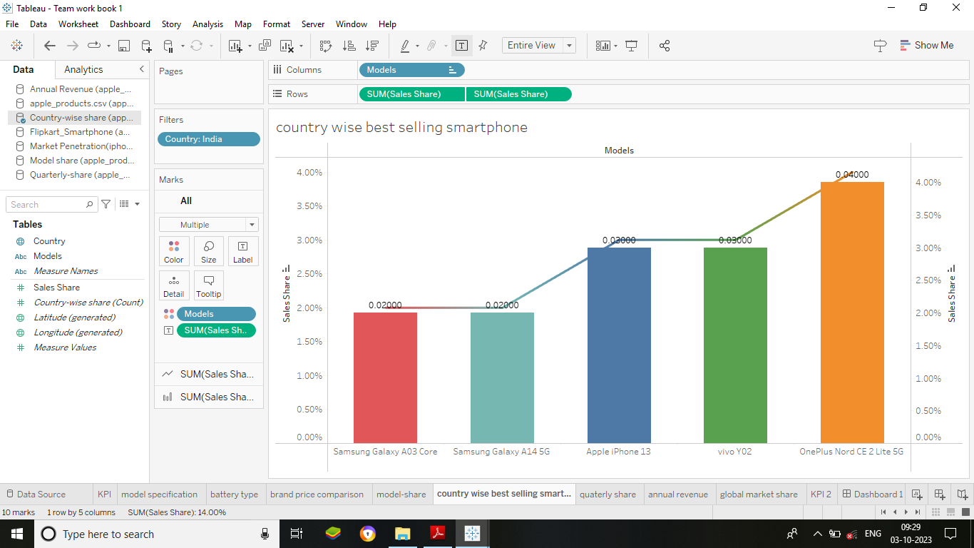

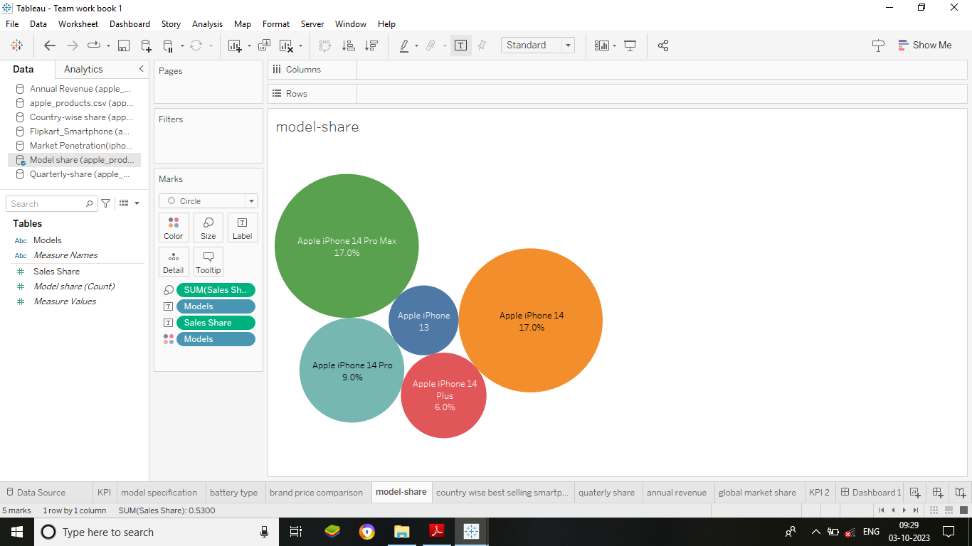

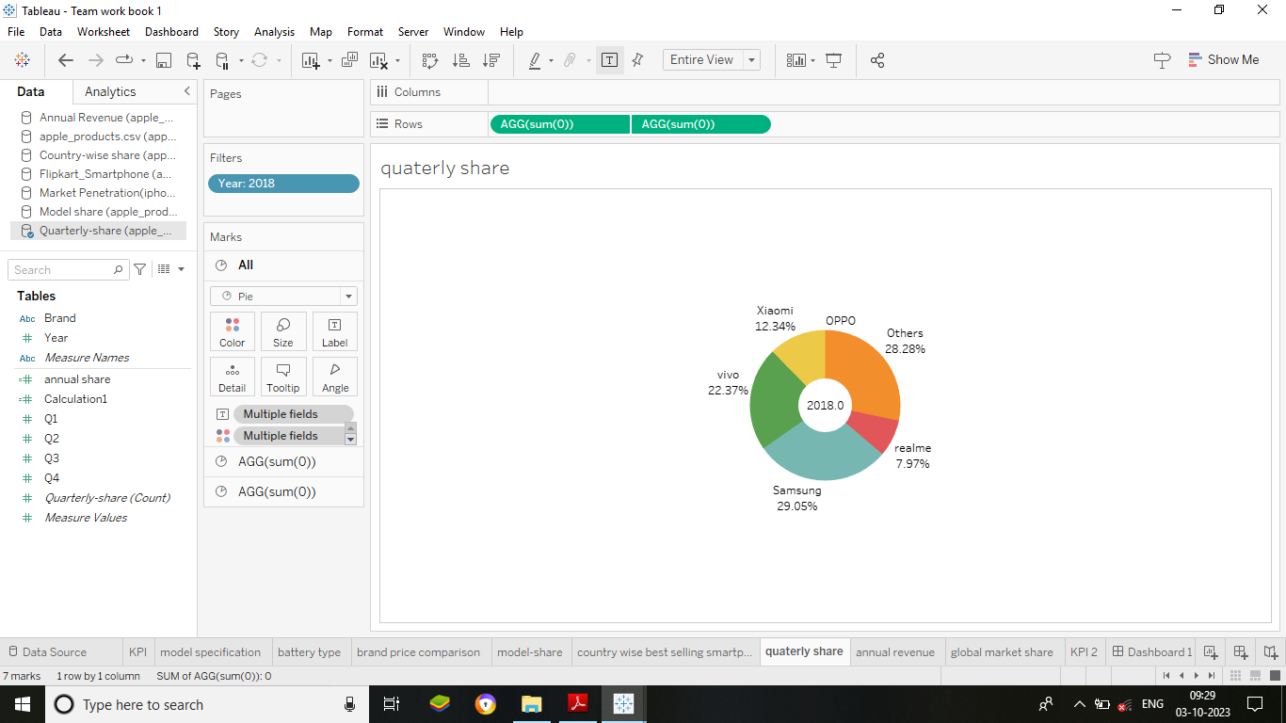

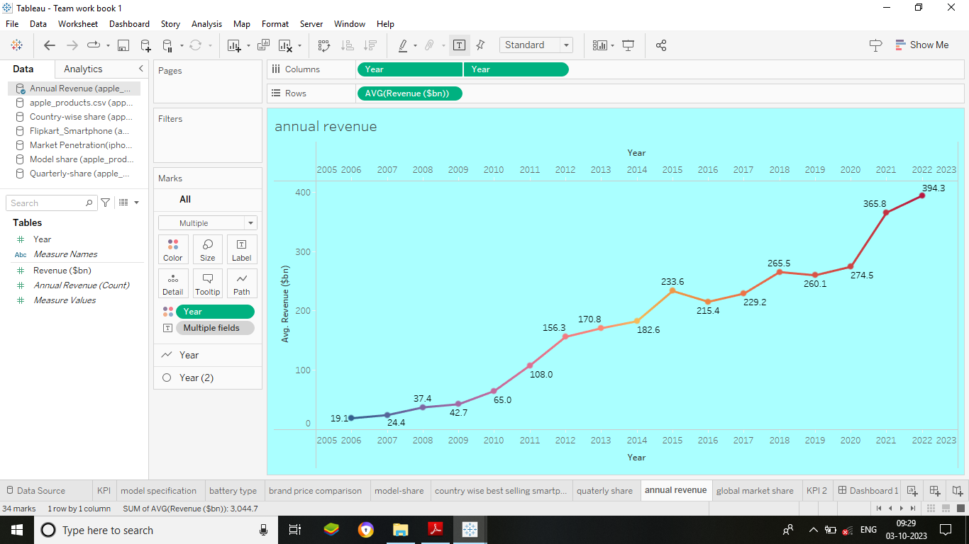

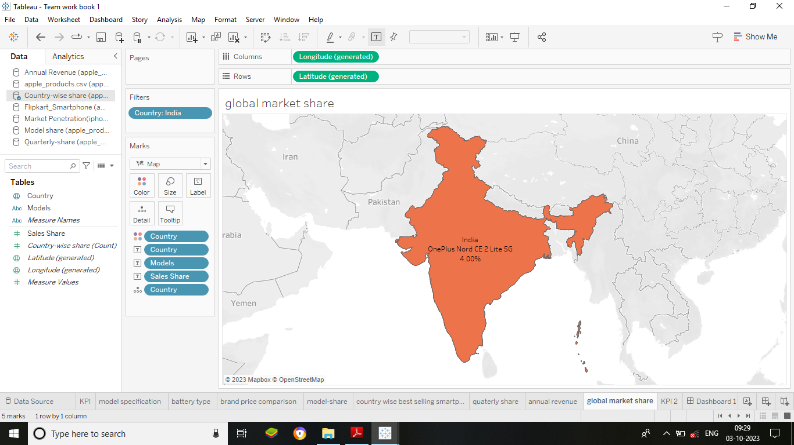

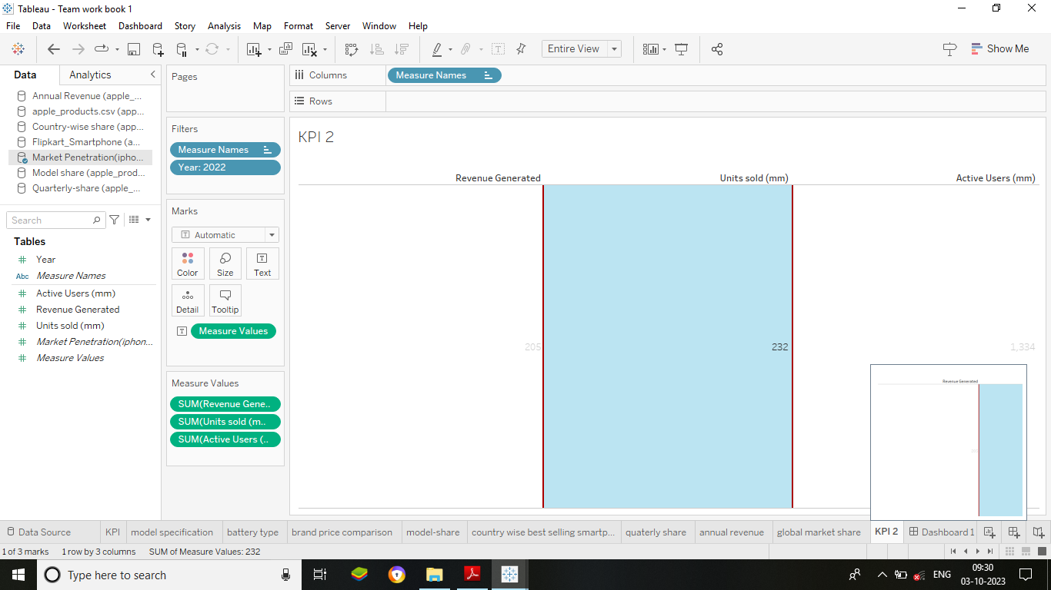

**Dashboards:**

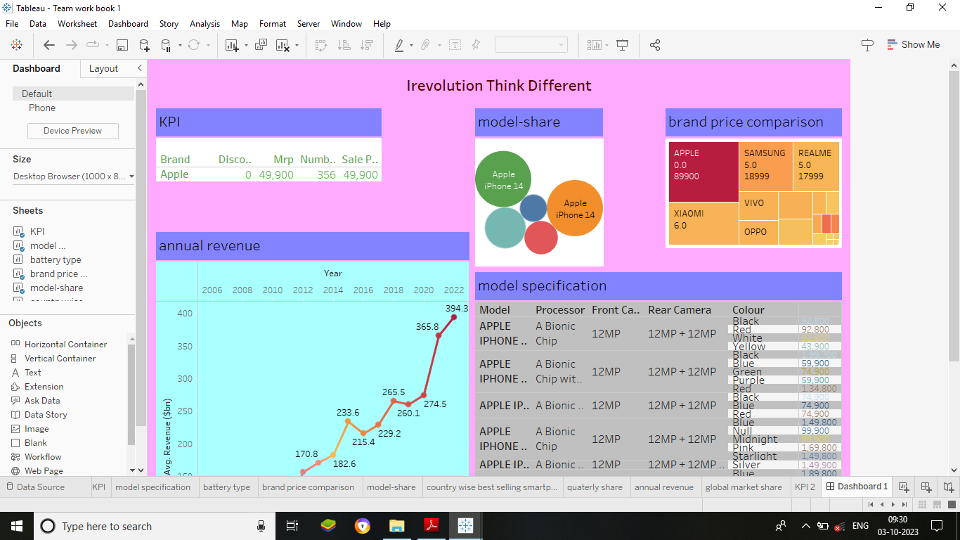

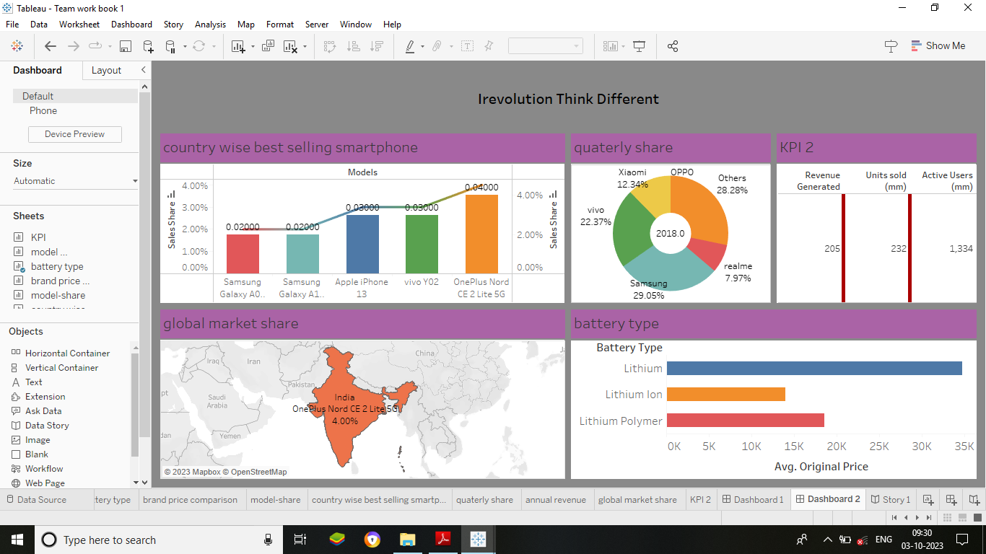

**Story:**

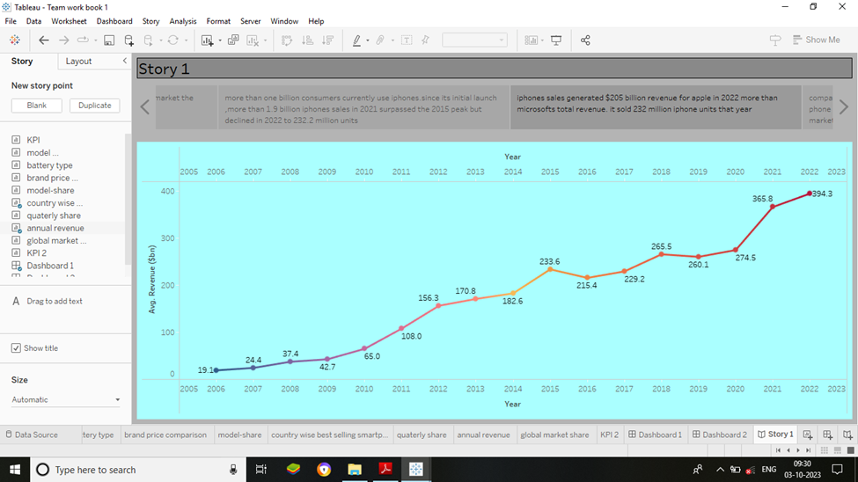

1. **Advantages & disadvantages:**

**Advantages:**

1. Each new iPhone model unveiling generates excitement and anticipation

among Indian buyers.

2 The iPhone smooth operating system is simple to learn and use.

**Disadvantages:**

1 This project shows us the impact of apple iPhone in India only. So, we

are unable to study the impact of other countries.

2 The iPhone is known to be fragile and prone to breaking if dropped.

**5 Applications:**

A software application that runs under IOS which is the operating system that powers apples

mobile devices. In most cases, any application that runs on an iPhone also runs on an iPad and

iPod touch.

**6. Conclusion:**

The phone has been a game changer in the technology world. It has revolutionized the way

People communicate and access information. The choice of whether of purchase on iPhone

Depends on the user’s performance, needs and budget.

**7. Future scope**:

IOS development has a bright future, as IOS is the most preferred platform where most of

the internet of things, Get complete compatibility and support moreover, ultramodern

home automation apps are getting developed using IOS only.